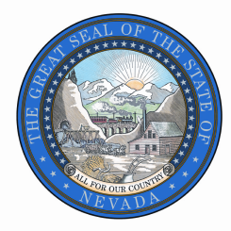
STATE OF NEVADA
STATE HISTORIC PRESERVATION OFFICE
Public Records Request

Deliver, Mail, or Fax to:

901 S. Stewart Street, Ste 5004

Carson City, NV 89701-5248

Fax: 775-684-3442

Attention: Rebecca Lynn Palmer, NV SHPO

Date of Request
Requestor Contact Information
Name:
Organization:
Address:
City, State, Zip:
Phone:
E-mail:

Records Requested:
Check one: Paper copies Electronic copies Certified copies Inspection (in person)
Please be specific and include as much detail as possible regarding the records you are requesting.

To complete an estimate, the agency will need the following information:
I will pick up | Please FedEx  Fed Ex billing number: | Please send USPS | E-mail (if format allows)

Statement
I understand there is a charge for copies of public records. I understand I will receive a written estimate for production of the records indicated above if the estimated cost is expected to be over $25.00, which I will be required to pay in full prior to inspection or reproduction. Materials will be held for 30 days. If not retrieved, advanced payment will not be returned.
Requester  Signature | ^{Signature Required}

