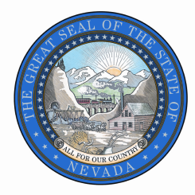

STATE OF NEVADA

STATE HISTORIC PRESERVATION OFFICE

Public Records Request

Deliver, Mail, or Fax to:

901 S. Stewart Street, Ste 5004

Carson City, NV 89701-5248

Fax: 775-684-3442

Attention: Public Records Officer, Jessica Axsom

|  |  |
| --- | --- |
| Date of Request |  |
| Requestor Contact Information | |
| Name: |  |
| Organization: |  |
| Address: |  |
| City, State, Zip: |  |
| Phone: |  |
| E-mail: |  |

|  |
| --- |
| Records Requested: |
| Check one:  Paper copies  Electronic copies  Certified copies  Inspection (in person) |
| *Please be specific and include as much detail as possible regarding the records you are requesting.* |

|  |  |  |  |
| --- | --- | --- | --- |
| *To complete an estimate, the agency will need the following information:* | | | |
| I will pick up | Please FedEx  *Fed Ex billing number:* | Please send USPS | E-mail (if format allows) |

|  |  |
| --- | --- |
| Statement | |
| I understand there is a charge for copies of public records. I understand I will receive a written estimate for production of the records indicated above if the estimated cost is expected to be over $25.00, which I will be required to pay in full prior to inspection or reproduction. Materials will be held for 30 days. If not retrieved, advanced payment will not be returned. | |
| Requester  Signature | Signature Required |